SHELDRAKE PRESS

STORIES OF HIS ABSURDLY INGENIOUS WORLD
BBC Radio Berkshire - Interview Transcript
Adam Hart-Davis, Bill Buckley, 22nd August 2018, 11.00 a.m.

BB: Let’s meet an award-winning historian and broadcaster now, who’s been a familiar face in our living rooms for several decades with TV shows ranging from Tomorrow’s World to What the Romans Did for Us. Adam Hart-Davis has now turned his attention to the eccentric inventor, William Heath Robinson, with a sumptuous new book called Very Heath Robinson: Stories of his Absurdly Ingenious World. He’s coming to the Henley Literary Festival very soon, at the end of next month, and he joins me now. How very nice to meet you, sir. Good morning.
AHD: Hello. Nice to be on.
BB: Thank you. We routinely say oh, that’s rather Heath Robinson, oh, that’s very Heath Robinson and so forth. But what exactly is your definition of the term?
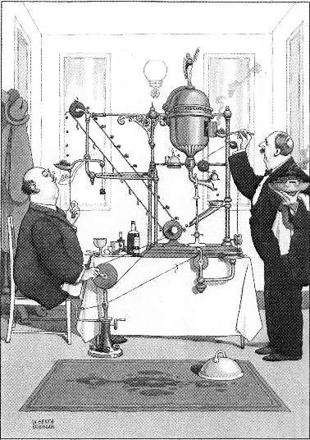
AHD: Well he was just an artist, he didn’t actually make anything, but he drew pictures of the most fabulous machines. My favourite picture of all is the very complicated machine for conveying green peas to the mouth. Now you would have thought you could use a fork or a spoon or something but no, no, this is an enormous machine that occupies a whole table. That’s absolutely typical of him to dream up some ludicrous contraption to do a really very simple task. And that’s why we call things Heath Robinson - if they’re really over the top.
BB: And what was his motivation in doing so? Other than the fun of inventing them and drawing them?
AHD: Well, he started by being an ordinary illustrator. He drew wonderful illustrations for Hans Christian Andersen, and various other important authors, Edgar Allan Poe and Rudyard Kipling and so on. But then some Canadian came and asked him to do some funny pictures and he was very suspicious of this guy. He thought he was a crook because he came from the other side of the Atlantic and he demanded payment in cash. He drew one of these pictures and the chap liked it and asked him to draw him another one and he suddenly realized there was real money in these comic pictures. He had a wonderful sense of humour, a ludicrous sideways way of looking at the world, and he just capitalized on this. He began to be asked by all sorts of companies in England, and indeed in Scotland, to draw pictures of how they did their work, you know, industrial machines, and he loved it. He drew absurd industrial machines that had some relation to the truth but actually were wildly optimistic and ridiculous. And the companies loved it. They paid him huge amounts of money. He got quite well off anyway.
BB: He was making a serious point as well though, wasn’t he? He was not exactly a political, but a social lampooner, could you say, of his time?
AHD: Yes, certainly. This was the time, basically between 1900 and 1940, [when] industry had advanced enormously. Things like cars were arriving - he had his first trip in a car in 1905. Radio came in, eventually television. Aeroplanes came in. The whole world was changing very fast and it looked as though he longed for a sort of bygone age. He didn’t like even steam engines. He wanted huge industrial machines to be powered by people pedalling and so on. It’s as though he wanted to go back in time to what it used to be like when he was a kid. We don’t know whether he really felt like that or whether he was just poking fun at all the modern machinery.
BB: He’s described as a hero of yours and I can see why you would like him... But what is it particularly about him do you think that got hold of you and at what age did you succumb to his charms?
AHD: I lived just outside Henley-on-Thames and we had thousands of books in the house – my dad was a publisher – but among them were two books of Heath Robinson pictures. I discovered these and I absolutely loved them, even then. This must have been at least 60 years, probably 65 years ago. I would go over them again and again and I still remember some of the pictures from those days. So when Sheldrake Press came to me and said, would I like to write a book about Heath Robinson? I said, ‘Yes! Wonderful!’ And they chose 300 pictures and I wrote the text to go round them to try to explain what his life was like, why he chose to draw pictures and what they were about. I loved doing that and researching it all.
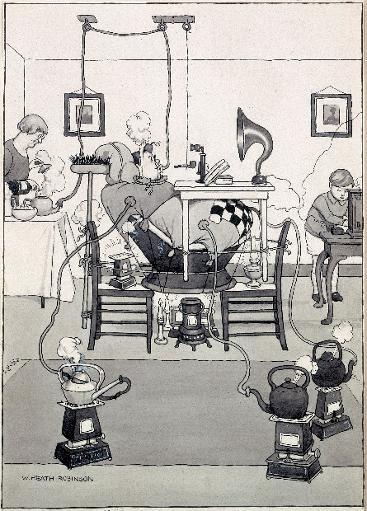
BB: Well, talking of what they were about, you’ve split the book up into various chapters. Shall we just talk about maybe two or three of those? Domestic Bliss. Now I would think first and foremost of Heath Robinson operating within the parlour, within the kitchen, that sort of environment. Would I be right?
AHD: Yes, absolutely. He has wonderful pictures. I mean, have you seen his steam bath on page 29? It is ludicrous. I mean, here is a fat bloke sat in a sort of armchair but he’s completely surrounded by eiderdowns and duvets and blankets and steam is being pumped in from several kettles, three or four, and he’s being heated by candles from underneath, and he’s got a pipe and he’s got a book, and he’s got a gramophone or radio playing at him and he looks blissfully happy. And he looks as if he’s about to catch fire. I mean, totally, totally silly.
BB: Meanwhile his wife and son are just going about their business in the normal way. She’s making a cup of tea which, of course, is helping with the steam. I’m not quite sure what the little boy is doing but they’re completely unconcerned by this which makes it twice as good I think.
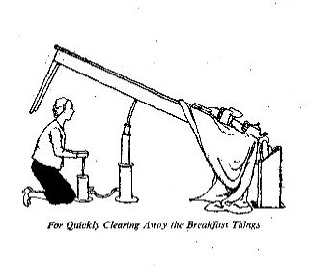
AHD: I think the little boy is operating the radio. But it’s typical that none of them is smiling. Almost nobody ever smiles in any of his pictures. It’s very serious. Take the easy way of clearing the breakfast [away] which is just about the first picture in the book, which is a hydraulic thing to lift the end of the table so the whole lot goes straight into a bin, which is a lovely thought.
BB: The satisfaction you would achieve from that if only you could do it in real life.
AHD: Absolutely. But the maid who’s doing it is very, very serious about it.
BB: He’s got this silly bath here but then on another page, he’s got quite a sensible bath. If there isn’t much water around, you can inflate something and it pushes the water level up in the bath. Now that’s not a bad idea.
AHD: It’s very clever, isn’t it? It is an enormous inflatable thing. He has to blow to get that inflated but then suddenly he’s got a bath full of hot water, and it’s overflowing and he’s very, very happy. It’s a very, very good idea. I think if I did that, it would just float up and I’d have less water and it would be all over me but no, with Heath Robinson it always works.
BB: We’ll talk about perhaps another couple of the chapters in a moment but hold the line for now. Talking to Adam Hart-Davis about Very Heath Robinson: Stories of his Absurdly Ingenious World.
- Plays ‘When a Man Loves a Woman’
BB: Speaking of a man who loves a woman, I’m talking to a man who loves Heath Robinson. William Heath Robinson who drew those incredible contraptions. Adam Hart-Davis has written Very Heath Robinson: Stories of his Absurdly Ingenious World. I mentioned that you’ve split the book up into chapters. We’ve discussed briefly Domestic Bliss but we haven’t got time to go through all the other chapters. Would you like to pick out perhaps a couple of others? Your favourites and a couple of illustrations therefrom?
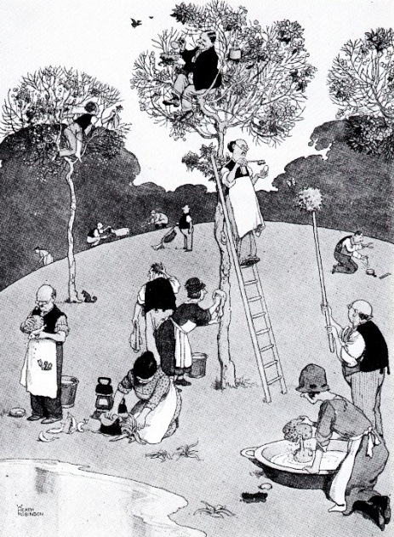
AHD: Well, let me tell you about one other picture, page 59. Here is a picture that has no gadgets at all. There are no machines. It’s ‘Spring Cleaning in Highgate Woods’ and here is a rural scene with trees and grass and so on. There is one chap dusting an egg, another chap who is cleaning off a whole nest full of eggs. There is a chap cleaning fish that have come out of a pond. A lady is ironing some leaves of a plant. There’s another woman sponging off a duck in a sort of bath. There’s a chap with a sponge trying to clean a butterfly. And then there are people vacuum cleaning the grass and it’s totally, totally absurd. I mean, why would you ever want to spring clean anything? Let alone, Highgate Woods? And the idea that all these solemn people are out there, none of them smiling. It’s very important, serious work, cleaning the trees. Ridiculous! It just makes me laugh all over again. I love it.
BB: One other example from the book? One other great picture?
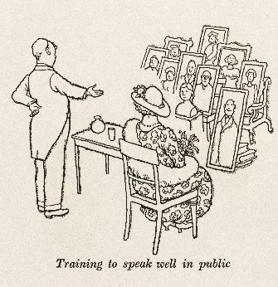
AHD: Well, there are so many it’s hard to… Take page 61. There is a chap practising public speaking. I have to do a lot of this, I give lectures all the time. And he is standing there and he’s at a table with a glass of water on it and there is a lady, the chairwoman presumably, sitting beside him with a hat and there are ten portraits, just pictures for him to practise speaking to. One imagines they’re going to clap at the end of the speech. I pretend that I do this every time I give a speech because I’m so nervous. I just think he has such silly ideas. They’re really joyous. Some of them [do] make serious points.
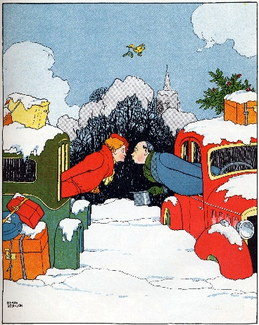
There’s a very important one on page 67. He’s very keen on testing. And here is a picture of two cars stuck in the snow and they’re testing the efficiency of mistletoe. There’s a bird flying overhead carrying a bit of mistletoe and there’s a woman leaning out of one car and a man leaning out of the other, having a very chaste kiss in between the cars. Again, totally silly.
BB: He’s quite prescient as well. I didn’t realize that, in effect, he’d invented the silent disco which we think of as a very modern phenomenon.
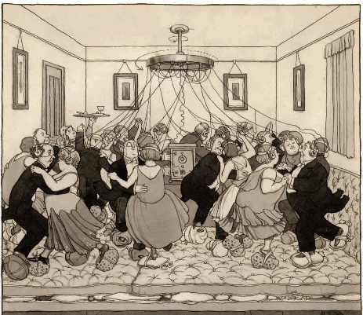
AHD: A lovely thought because people were living in flats. There was a real problem because during the 19th century, when he was born, the population of England had gone from eight million to 30 million and most of those people had come to live in towns. So they were living in tiny houses and in maisonettes and in flats and, of course, one of the main problems of living in flats is the noise. If you’ve got people having a disco over your head then you know all about the noise. So he’s got this lovely scene of them all wearing earphones so there are no speakers blaring out noise and great, big sponges and cloths on their feet so they’re not stamping on the floor. I once was in a hotel in Italy, we were filming down there, and they put us in the ground floor of this hotel. And I was actually underneath the ballroom, which had a marble floor, and there was a wedding going on. So there were about a thousand people in stiletto heels stomping over my head all night. I will never forget it. So I welcome the silent disco.
BB: I love his other ideas for maximizing space in flats. He’s got a dinner party where there are cut-out holes in the table so you just lay the table over the people and they start to eat their dinner. And he’s got all kinds of extensions built out so that you can have a garden or keep a cow five floors up outside.
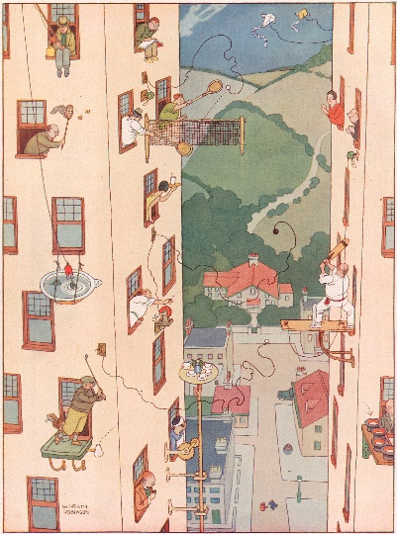
AHD: And playing sport, indeed there are people who are playing sport off their window ledges: golf, cricket and tennis. Absolutely wonderful. Given this problem of living in a flat, he invents all sorts of stupid ways to make it work. There’s one, if you only have two people to dinner then you simply put a great big mirror at each end of the dinner table and it looks as if there are a thousand people there.
BB: And space is at a premium today like never before so his wise words live on. Books have been written about him before, so what new perspective did you particularly want to bring to the subject?
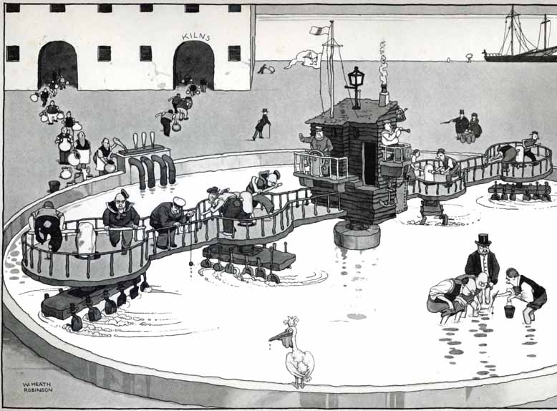
AHD: The previous ones are mainly biographies or collections of his pictures with a description of the picture. I wanted to dig into it a bit and find out what might have motivated him to draw these and how each one came to be. I looked up the firms that he’d drawn pictures for, and I looked at the sort of subjects he’d done and so on. That was really interesting. For example he drew a series of eleven pictures about a cement works up near Hull. Now I’ve actually been to the same cement factory, and I’ve seen how it’s done. His drawings are wonderful because they’re very much like the real thing but, of course, with ludicrous additions and changes. So it’s all human-powered and because it’s called Pelican Cement, there’s a pelican in each picture overseeing, making sure it’s done right. I just found that fascinating. I’d be looking up the original company and how it happened and it all made the whole thing much more powerful for me.
BB: You’re on your way, as I mentioned, to the Henley Festival and you’re performing at 4.30 p.m. on Friday 5th October. Adam Hart Davis, Very Heath Robinson. Tell me about talking at festivals about books that you’ve written. What’s it like? What sort of responses do you tend to get?
AHD: Oh, it’s great fun because basically you’ve got a self-selected audience. People look at the programme of the festival and if they’ve never heard of you, or they don’t like you [then] they don’t come. So the people who come to your lecture probably either like you or like the subject so it’s a nice, friendly audience. If you’re lucky, you’ll have two or three hundred people. It depends on the size of the festival, on the size of the room. But a couple of hundred is really nice and anything down to 50 is still very pleasant, as you can talk to them individually and you can get questions back. The great thing is to try and make them laugh. I usually start with a terrible joke. The trouble is if I tell you now then anyone’s who’s listening won’t be amused. I don’t want anyone to think I’m taking it too seriously. I don’t take anything too seriously, least of all myself. Just as Heath Robinson didn’t. So I want to make quite sure that people realize that this is all a bit of a laugh and I’m here for fun and I hope they’re here for fun too.
BB: Well, if you can’t get a fair few belly laughs out of a subject like this, I’d be very surprised. Have a lovely time at the Henley Festival. In the meantime the book is Very Heath Robinson: Stories of his Absurdly Ingenious World by Adam Hart-Davis, published by Sheldrake Press. Very nice to have met you this morning. Thank you so very much.
AHD: Great fun to be on. Thanks very much for having me.

